HAPPY THANKSGIVING!

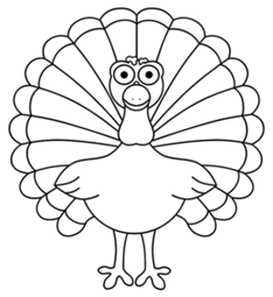
Feather Fractions
- Use at least 5 different colors to color the feathers of the turkey.
- Fill in the table below.
- Color the rest of the turkey!
Color | Fraction of Total Feathers | Simplified Fraction (if possible) | Percent | Decimal

